**Application Deployments**

**Terms**

* Capex: Capital Expenditure
* Opex: Operational Expenditure
* Physical Server
* Hypervisor
* Virtual Machine
* Return on Investment (ROI)

**Evolution**

* Generation 1: Directly run on Physical Servers
  + Directly run on physical servers
  + If your application is not utilizing hardware completely, ROI is very long  
    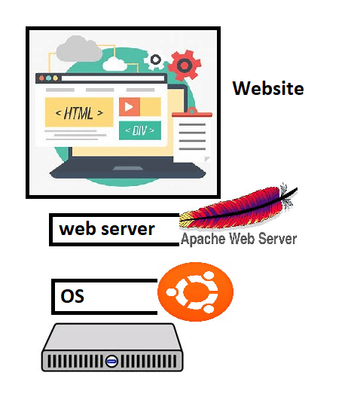
* Generation 2: Hypervisors create virtual machines and applications installed in virtual machines
  + Hypervisors perform hardware virtualizationa and provide
    - virtual cpu
    - virtual ram
    - virtual disk
    - virtual network
  + In the isolated area created by hypervisor, we can install os and necessary softwares
  + Application can be installed and used from here
  + Better ROI
* Generation 3: Containers: These are isolated areas which look like vms but the container is an isolated area which has virtualized os.
  + Applications running in Containers will not feel the difference
  + We can run more applications on a single box

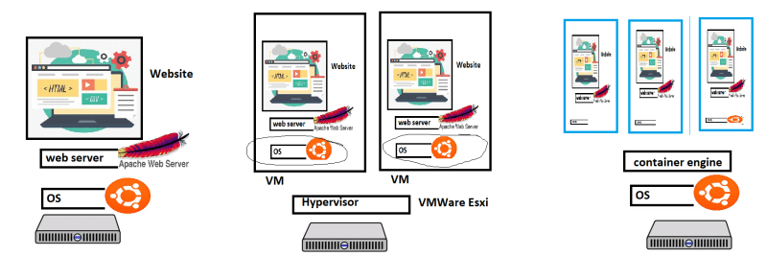

**What is docker?**

* Docker (dock worker) is used to create containers which is standard way of packaging any application
* Application can be any of the below but have a standard way of packaging i.e docker image.
  + developed in any technology
  + developed on any server
* Packaging in docker image format helps us to run our application  
  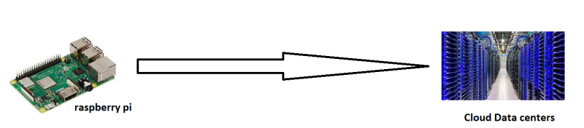

**Expectations from you in terms of Docker**

* Containerize any application run by your organization.
* Manage Data, Security and Networks for containerized applications.
* To acheive the above expectations, we need to use
  + docker and understand how it runs and creates containers
  + play with docker aroud networks, data and security
  + apply them to our application.

**Manual deployment >** Run apache server (VM)

* Create a vm (ubuntu) and ssh into it

sudo apt update

sudo apt install apache2 -y

* Now navigate to http://<publicip&gt;  
  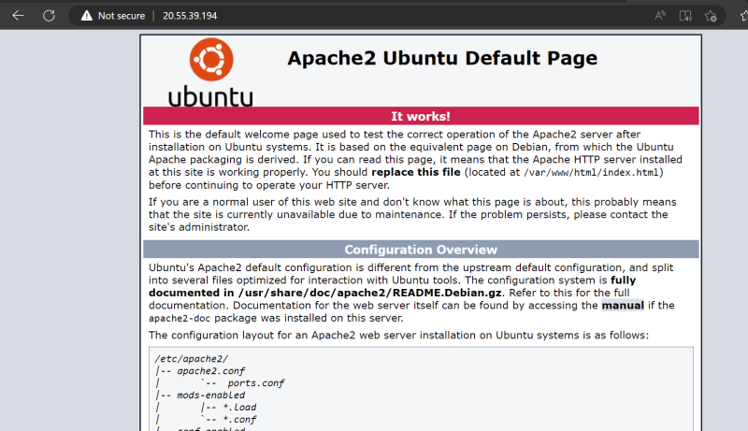
* Now let’s try to also install nginx